**CHERIAN XAVIER**

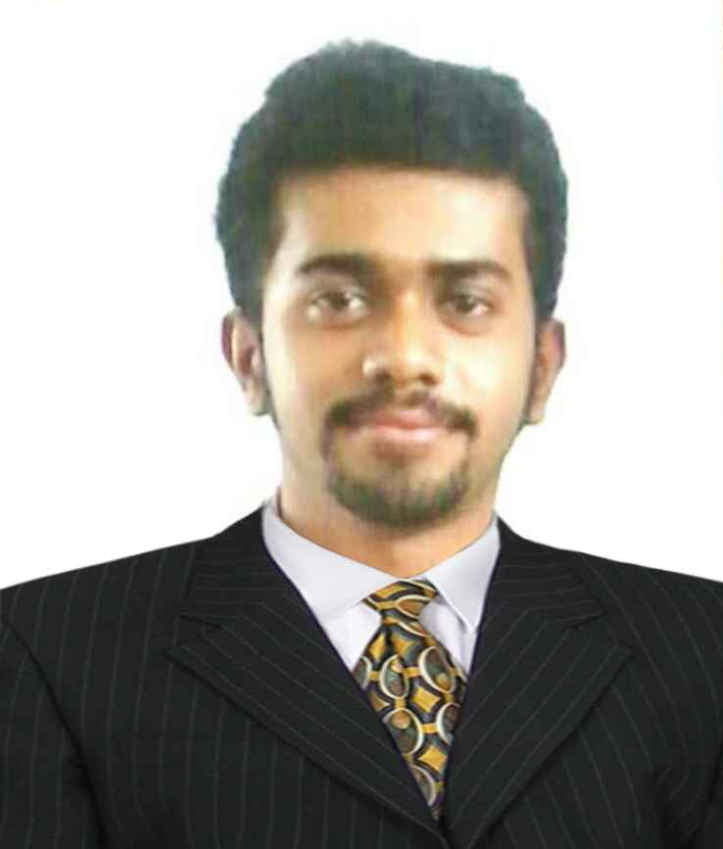

####  +91 9481110065

####  cherianxavier12@gmail.com

**CAREER SUMMARY**

A passionate teaching professional with 7 years of total experience across multiple domains, inclusive of 5 years of experience into teaching MBA, BBA aspirants and 2 years into HR domain having expertise working on HR and Admin role now seeking a challenging opportunity with a institution so as to contribute the best of my knowledge and abilities and upgrade myself to the latest trends in providing education.

**WORK EXPERIENCE: St Joseph Engineering College Mangalore. (January 2023-Till date)**

**Designation: Assistant Professor**

**Department of Business Administration-MBA/MBA-IEV**

**WORK EXPERIENCE: Anjuman Institute of Technology & Management, Bhatkal. (September 2017- January 2023) Designation: Assistant Professor MBA/BBA department**

**Subjects Handled:** Human Resource Management, Services Marketing, Compensation and Reward system, Integrated Marketing Communication, International HRM, Managerial communication, Organizational Behavior, Emerging exponential technologies, Personal growth & Interpersonal effectiveness.

**Articles Published:**

* A study on impact of layoff a negative impact on organizational branding-A theoretical assimilation International Journal of advance and applied research (ISSN: 2347-7075 Vol. 4 No 32)
* Challenges and opportunities for E-Leaders through effective virtual teams in the International Journal of Engineering Technology Science & Research IJETSR (ISSN 2934-3386 Vol. 5 Issue I).
* A study on future prospects of Brick & Morter Retail versus E-tailing in India.

**WORK EXPERIENCE- Prakruti Remedies Pvt. Ltd a Pharmaceutical Manufacturing Company (September 2016-September 2017)**

**Designation-HR & ADMIN**

**Reporting to the Managing Director.**

**Responsibilities-**

* Managing the factory consisting of 300 employees.
* Organizing induction for the new employees and training them.
* Making the joining formalities and maintaining appropriate files.
* Scheduling and conducting the interviews for candidates.
* Payroll processing through a HRMS (Human Resource Management System) named Saral Pay Pack.
* Processing the Provident Fund (PF) for employees through the EPFO portal and generating electronic online challan for paying the PF due.
* Initiating the PF withdrawal, PF transfer and claim process.
* Deducting the Salary advance paid and loan amount deduction.
* Leave management and calculation of earned, sick and casual leave through leave cards and data base updating.
* Setting up the CTC for the new joiners through negotiation between the candidate and the management.
* Processing the Professional Tax to be paid of the employees.
* Recruiting through sources like internal hiring, Job fairs, references, advertisement through the media and social networking.
* Registering employees on the Biometric machine for attendance check.
* Generating the attendance report of employees at the month end.
* Generating the Pay slips for each employee.
* Calculation of monthly expenses for the sales team.
* Generating orders for office stationery and identifying prospective vendors for procurement of materials.
* Coordinating with the regional PF Office, Labor Office, Food Safety and Standards Authority of India.
* Processing the ESI welfare scheme for employees and making monthly contribution.
* Co-ordination with legal advisor for handling employee cases in the district court.
* Renewing the Factory license, Drug License, FSSAI license.
* Processing the full and final settlement of the exited employees.
* Organizing daily meetings of operational activities.
* Performing manual calculation of CTC of employees through MS Excel and interpreting the same to HRMS.

**WORK EXPERIENCE- Avazzar Consulting Pvt. Ltd. (October 2015 – July 2016)**

**Designation- HR Recruiter**

**Responsibilities-**

* Recruiting candidates for IT and NON-IT skills
* Searching on job portals and initial screening of candidates.
* Conducting regular follow-ups.
* Cold calling and client interaction
* Preparation of reports, scheduling interviews.
* Managing complete recruitment cycle.
* Mass mailing candidates and job posting.
* Preparation of job description for various jobs.
* Negotiating with candidates on CTC.
* Hands on experience in Microsoft word, excel and PowerPoint.

**TECHNICAL SKLLS**

* Installation of Windows XP/Vista/7/8/10.
* Troubleshooting Basic network issues in LAN and Wifi.
* Assembling Desktop Computers.
* Applying patches and cracks for softwares.
* IP address configuration in computers.
* Troubleshooting Desktops and laptops.
* Identification and Installation of Drivers for optimum hardware performance.

**ACADEMICS:**

* **Master of Business Administration (M.B.A.- batch 2014-15 with H.R. specialization)**

College: Girijabai Sail Institute of Technology, Majali, Karwar,Karnataka

University: Vishweshwaraya Technological University, Belgaum

* **Bachelor of Computer Application (B.C.A.-2013)**

College: Shivaji B.C.A College Baad, karwar

University: Karnatak University Dharwad

* **Higher Secondary School(2010)**

College: Shivaji Arts, Commerce & Science College, Karwar

University: Pre-University Education Board

* **Secondary School (2008)**

School: St. Joseph’s Higher Primary School Karwar.

University: Karnataka Secondary Education Examination Board

**CERTIFICATION COURSES:** Diploma in Computer Application (DCA)

**Internship/Project:**

Worked as HR Intern in Sterling Holidays Resort at Karwar Emerald Bay and did a project on the topic employee engagement for a period of 2 months while pursuing M.B.A with HR specialization.

**Responsibilities:** Leave Management, Payroll, PF, ESI, Statutory Compliance, HRMS, Employee relationship management.

**Project work during graduation B.C.A**

1. Project name – VISIONSOFT
2. This project was mainly developed for our client named ‘DURGA OPTICIANS’ located at karwar for converting his manual entries on books into a computerized form. It also consisted of the feature of generating computerized bills for delivering it to its customers. The software developed was a Database Management Software.

**PERSONAL DETAILS:**

Date-of-Birth: 28-01-1991

Gender: Male

Nationality: Indian

Languages Known: English, Hindi, Malayalam, Kannada and Konkani

Address: PANTHATHALA, MUTHOLY P.O

PALA, KERALA STATE, INDIA.

PAN Card No: AADPX2435R

**PERSONAL SKILLS:**

* Able to influence others and implement HR change
* Have the confidence to be an able negotiator and get things done.
* Able to work under pressure and multi task.
* Capable of conducting training and presenting to employees.
* Interpersonal with good communicative skills

**DECLARATION:**

I hereby declare that the above furnished details are true and correct to the best of my knowledge.

Date:

Place: Karwar **CHERIAN XAVIER**